Simulation of Spot Prices
To model spot prices, the FEA postulates that they mean-revert to their corresponding prompt-month futures contract, F_{t}:
(Eq. 4) where “a” is the spot mean-reverting rate; “” the spot-to-prompt month correlation, “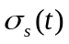” the volatility of the spot price at time t; and finally 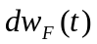 and 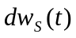are independent Brownian motions for prompt-month futures and spot prices, respectively.

Parameters Estimation
- Estimation of the spot mean-reversion rate
We estimate the mean-reversion rate “a” by regressing 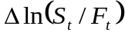 on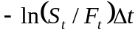, using historical spot and prompt-month prices.

- Estimation of “”, the correlation coefficient
From the fitted linear model used to estimate “a”, we then compute the residuals as the difference between the values of the response variable and fitted values, 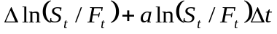.
Next, we calculate Pearson’s linear correlation coefficient between the residuals and the prompt-month log returns, 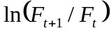. The spot-to-prompt month correlation for a given month, January for instance, is taken to be the average of all January spot-to-prompt months’ correlations in our historical dataset.

- Estimation of the spot volatility at time t.
The spot volatility is calculated on a monthly basis. In other words, we first aggregate the daily spot log-returns by month and year (e.g. Jan03, Feb03… July06). Jan06 volatility is estimated as the standard deviation of Jan06 daily log-returns. Finally, the volatility of January is taken to be the average of all January volatilities in our historical dataset.

- Spot Simulation
Thus far, we have estimates for the spot mean-reversion rate, monthly spot-to-prompt month correlations, and monthly historical spot volatilities. We simulate spot prices from the discretized version of Eq. 4:
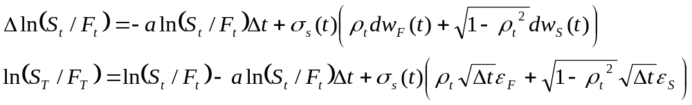
where 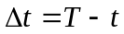 ,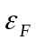 and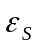 are two independent standard Gaussian variables for prompt-month futures contracts and spot prices, respectively.
Letting 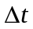be 1 day and the volatility being daily,
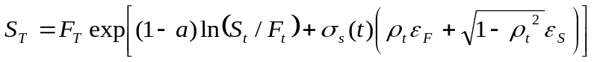 (Eq. 5)
This final expression of S_{T} is not an exact solution and is subject to discretization error. Furthermore, the simulated spot prices are meaningless; in our dataset, they oscillate between 0 and Infinity.
We replaced 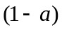 in (Eq. 5) by 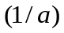. The resulting expression for S_{T} is given by:
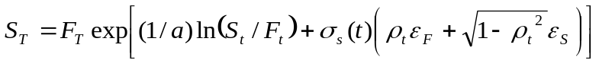 (Eq. 6)
It is true that this change has no mathematical justification; however, the simulated paths are striking. The average of all simulated spot prices for a given month is extremely close to the prompt-month futures contracts prices. The figure below illustrates few simulated paths.
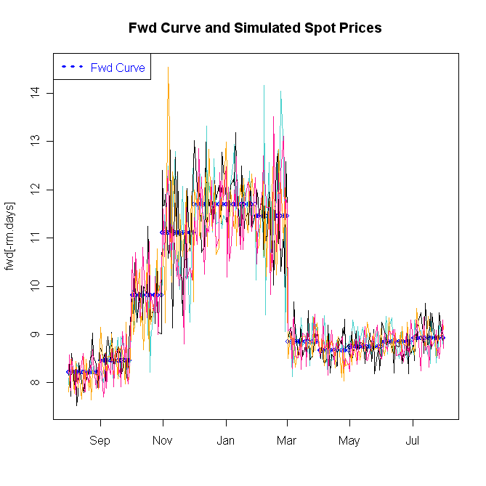
The key inputs to the spot simulation are the monthly volatilities (user-specified), which cause the most volatile months to spike.
For further details on the estimation of the parameters of (Eq. 4) and the spot prices simulation, please refer to the R file “FEA.spot.prompt.analysis.r” which is found in the directory: “S:\Risk\Temporary\Spot Simulation”.

We have also implemented a simpler model than the FEA’s to simulate spot prices based on a current forward curve. This second modeling approach postulates that spot prices follow a geometric Brownian motion:
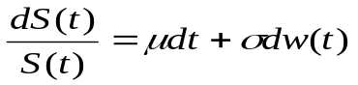
Using Ito’s lemma, we have (Eq. 7)
To be consistent with the forward prices observed in the market, we take 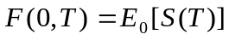. This implies
Therefore, given forward prices with different delivery dates F(0,1),…F(0,N), we can simulate using:
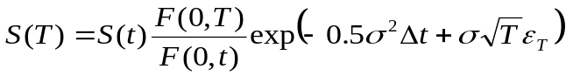 (Eq. 8)
The spot prices simulated from (Eq. 8) do not follow the evolution of the forward curve.
The following plot shows few simulated paths from (Eq. 8).
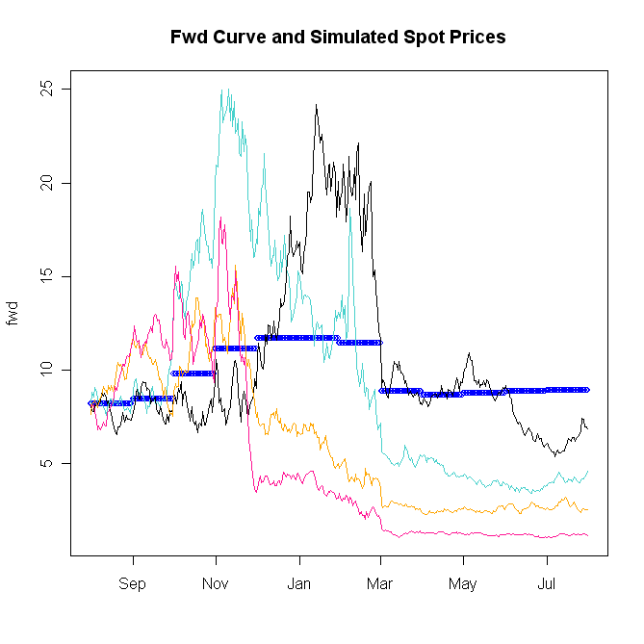

FEA User Guide, Technical Reference, page 63.
The estimation of the spot mean-reversion rate and spot-to-prompt-month correlations are based on Josh Gray VBA model.

